CS 1050 Technical Documentation

Click table of contents below to refresh after adding more headings
Overview
General Resources
SD01 Software Development and Tools
Version Control
IDE and Debugging
Analyze requirements
Design and Testing Plan
Implement Quality Documented Code
Module 1: Programming Fundamentals and Tools
L02 Language fundamentals
Parts of java program
Variables
Constants and Conventions
Programming Language Elements
Integer Division and Modulo Operator
L03 Primitive Data Type Conversion and Casting
L04 Primitive Data Type Conversion and Casting
Memory Concepts
Heading 3 Example
Module 2: Predefined Classes, Methods, and Decision Structures
METHODS
Classes
L05 Classes, Objects, and Methods
LO6 Math Class, Characters, and Strings
- Math
L07
L09 Logical Operators, Multi and Nested if-else and Switch Statements
Module 3: Loops and Methods
Heading 2 Example
Heading 3 Example
Module 4: Arrays
Heading 2 Example
Heading 3 Example
Module 5: Classes and Objects
Heading 2 Example
Heading 3 Example

Overview
When you add information in your own words demonstrating your understanding. Do not use exact words from lectures or images from lectures.

DOs and DON’Ts
DO: Provide clear and simple explanations in your own words (be concise)
- Use short sentences, small paragraphs
- Use lists and tables to organize information
- Use standard industry terms but explain in simple language
- Use AI Tools to help you learn but use lectures first
DON’T copy my explanations from the slides as yours.
DO Use Code Snippets and Visuals to reduce lengthy explanations:
- Include examples you explored or created
- Include comments to describe parts of code
- Include Screenshots such as from your debugger
- Include your own drawings such as for memory, arrays, etc.
- Include images you have AI create (cite that AI created)
- Include images from the Internet with the link
DON’T use my slides as your image and explanations
DO Include Resources that give steps or help explain concepts
- You can include resources given in the lecture or find your own but
  - Include website link with summary
  - Include links to videos with summary of content
DON’t use AI to create your technical documentation.

General Resources
- Your first source should always be your course lecture slides and documents or links to information in the lectures
  - F26_CS1050_Student_Course_Resources
  - Java Environment Setup
  - Introduction to Programming with Java - use the sections shared with you to practice ideas from the lecture.
- Next resource is to see Deb or learning assistance during office hours
- If you're unsure whether a source is trustworthy, ask your instructor first. ⚠️ Avoid These Sources
- TPointTech https://www.tpointtech.com/
- W3Schools – Java, syntax, data types, etc.:
https://www.w3schools.com/java/
- Sites without a known author or date
- AI-generated blogs that do not cite documentation
- Use of AI should be last as it will probably give you information you haven’t learned or understand. It is expected you will be documenting concepts from class and book using your code examples.

Other Tools you should use:
- Eclipse
- Visualize Java Code - used to step through code and edit code

SD01 Software Development and Tools

Version Control
- Use version control management tools (Git/GitHub) to manage and document development with GitHub Desktop.
- Cloud backup (Github)
- Personal server storage (Git)
- Eclipse Cheat Sheet

IDE and Debugging
- Write and debug programs in IDE (Eclipse)

Analyze requirements
Analyze requirements(user stories and acceptance criteria) to break problems into smaller testable tasks

Design and Testing Plan
- Apply Test-Driven Development (TDD): Create unit test cases, design algorithms in pseudocode, implement code (structured, readable and documented), debug and unit test incrementally
- Develop a documented plan by creating unit test cases and algorithm designs
- Use UML to design and implement multiple class programs.

Implement Quality Documented Code
- Apply Java naming conventions for variables, constants, methods, and classes.
- Write comments at top of file and inline comments to document code.
- Use constants and variables and avoid hard coding literals
- Document method code following javadoc commenting
- Use Single Responsibility Principle (SRP) and Do Not Repeat Yourself (DRY) to implement modular, readable and testable solutions

Module 1: Programming Fundamentals and Tools
Add the information to demonstrate the following objectives and organize with headings:
- Declaring, initializing, and assigning variables.
- Compare constants and variables
- Order of operations, integer division and the modulus operator.
- Memory allocation based on data type and potential overflow errors during program execution
- Select appropriate numeric primitive data types (int, double) based on the type of data and required precision.
- Apply assignment operators and basic arithmetic operators to form valid expressions.
- Implicit and explicit conversion rules and casting
- Mixed number (doubles and integers) operations
- Standard output using System class and print methods.
- Identify different types of Errors
  - Syntax error. Include a screenshot of your IDE showing there is a syntax error
  - Runtime error. Include a screenshot of your IDE showing
  - Logical errors.

L02 Language fundamentals

Parts of java program
- Curly brackets “{,}”: used to tell the computer that the statements inside the brackets are all together.
- Start with one after your class and end with one when you’re finished.
- Another set of brackets for the main method.
- The two forward slashes “//” are used to makes comments or notes and help you organize.
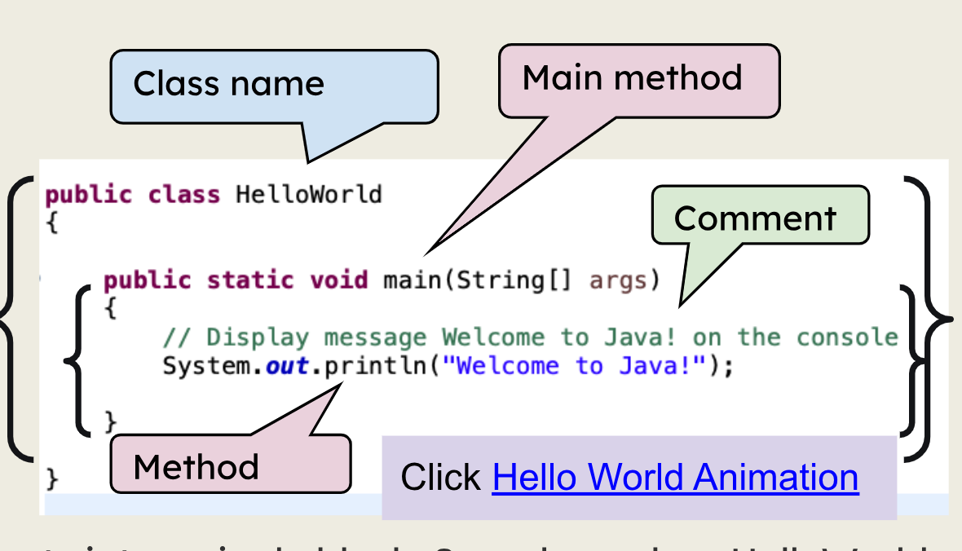

Variables
- Variables store a value
- What type of data is being stored

Constants and Conventions
- Constants are a stored value that is not changed (it is CONSTANT)
- Conventions are used in all CAPS and meaningful “final int” = constant “RANDOM_MULTIPLIER” = Convention
- Division with integers- A remainder (modulo) operator “%” / a 5 % 3 yields 2
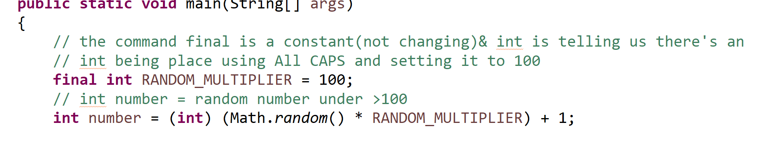

Programming Language Elements
- Key Word: A word that has a predefined meaning in a specific coding language (Final)
- Syntax: The rules for words and phrases in a programming language
- Punctuation: Exactly how it sounds; punctuation marks in programming language (e.x. ; )
- Operators: Symbols or keywords that are used on variables ( +, -, *, etc). Pretty much math calculations or arithmetic.
- Identifiers: Words or names that are made by the programmer. So if I made a variable int age = 25; then the identifier is age. I can change “age” to whatever I want it to be.

Integer Division and Modulo Operator
- Dividing in java isn’t like regular division
- If you were to do 16 % (divide) 5 you would get 1 because of the Modulo Operator
- You get the answer “1” because you’re counting the remainder
- 15 % 5 = 0
- 5 * 3 + 1 = 16
- 5 * 3 + 0 = 15

L03 Primitive Data Type Conversion and Casting
- Running programs

L04 Primitive Data Type Conversion and Casting

Memory Concepts
Casting
- Implicit Casting (Widening): This is automatically done (unlike explicit). You can place a smaller into a larger i.e. int smallNumber = #
double bigNumber = smallNumber
- Explicit Casting (Narrowing): You start with a double and placing that into a int
(Remember: we use a decimal since its double and its an integer so we use camel case) double wholeNumber = 43.23
Int wholeNumber = (int) preciseValue
- It will not automatically adjust for you, so you have to tell the computer that you want to take that double and “narrow” it down to a integer

Heading 3 Example

Module 2: Predefined Classes, Methods, and Decision Structures
Add the information to demonstrate the following objectives and organize with headings:

- Using built-in classes (System, Scanner, String, Character, Math) and their methods; parameters and return values
- Distinguish between characters (char) and Strings.
- String as an array of characters and use String class methods.
- Use Boolean values and relational operators to compare data.
- Distinguish between if-else, multi-way if, and nested if statements to control program flow.
- Scope of variables
- Use logical operators (&&, ||, !) to combine conditions.
- Use of Switch statements for multi-way selection

METHODS
- Notice parentheses
- Notice the
- System.out is a printsteam. Tells the computer we are reaching out to use the default console.
- System.in tells the computer that we are using an inputstream. To use the default keyboard. The system now knows you want to use to keyba

Classes
- Used as a blueprint
- “Scanner”

L05 Classes, Objects, and Methods
- The identifier for the class starts with a capital letter
- Uses CamelCase
- The file must match the class name
Predefined classes and methods
- The system class is a default language package
- When you do System.in refers to the default keyboard input
- While System.out refers to that default system output (println, print)
- When using System.in you must first put in a new Scanner class
- That Scanner class is not a default and must be placed using java.util
- You can see line 31 the Scanner class being implemented while in line 9 java.util is calling to be imported.
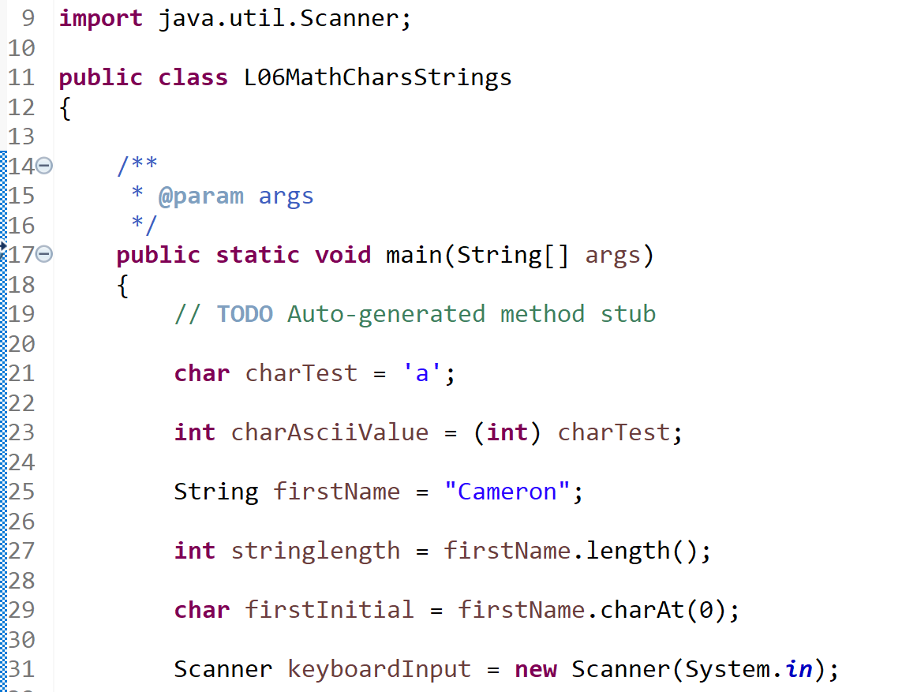
Formatting data with printf
- %f is a floating-point number or like a double
- %f rounds up a decimal
- %b is a boolean value such as True or False (don’t know how that would be used)
- %c would be a character ‘a’ (is this also a char?)
- %e is a number in scientific notation
- %s is a string (see L06)

LO6 Math Class, Characters, and Strings

Math
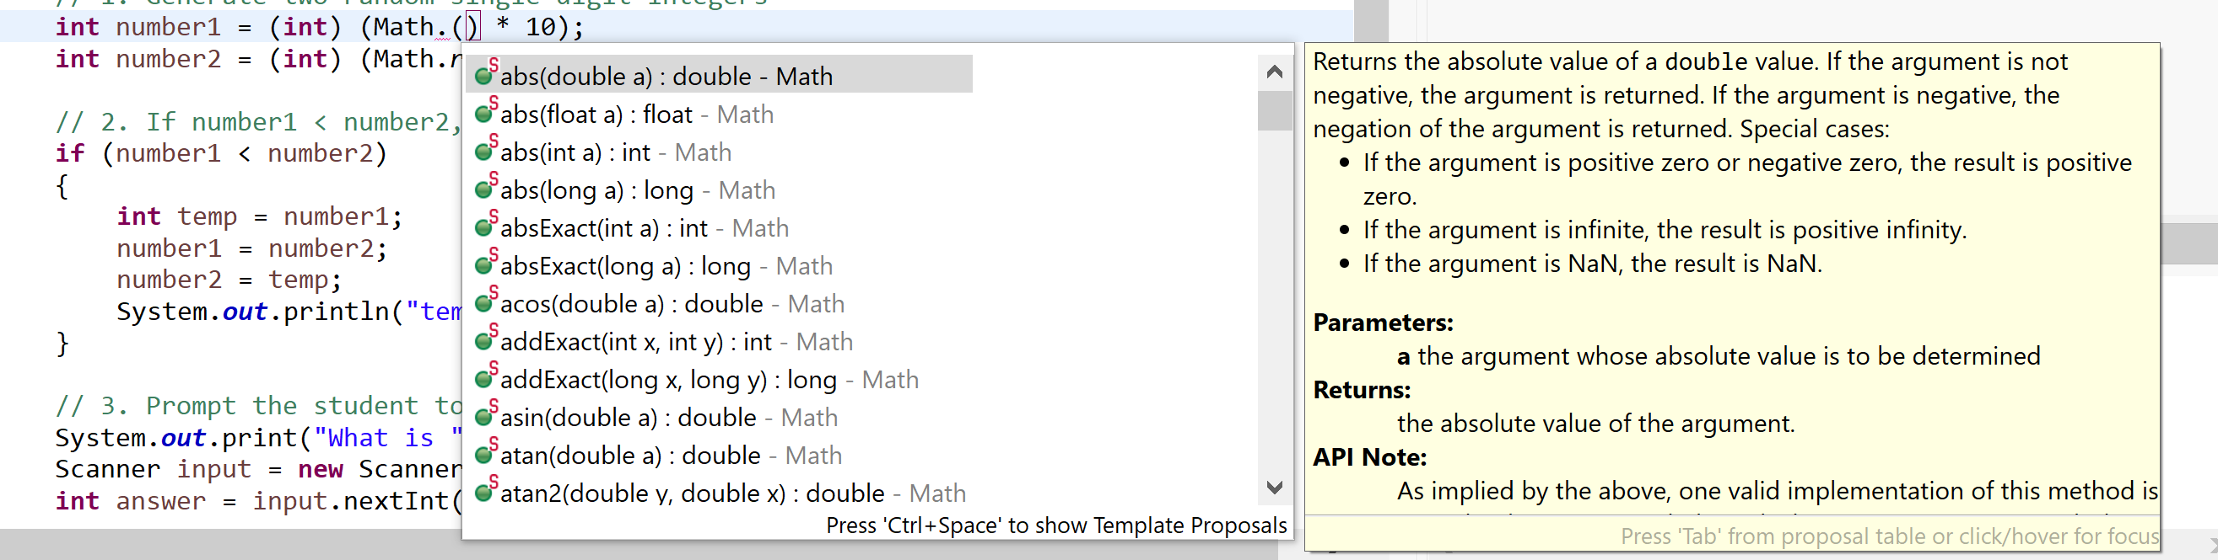
- The class “Math” has a list of predetermined methods
- Static Methods
- Allow you to call a method without making an object
- To call it, you must use the Math.random()
- The main method is also a static class

- In the example you see that there are two integers being made “number1 & “number 2” out of 10

L07
Boolean
- Use brackets with Booleans like you would with classes and methods
- Must start with a bracket and close with a backet
- Don’t put semicolons at the end of a If or Else

L09 Logical Operators, Multi and Nested if-else and Switch Statements
- || means “or”
- && means “and”
- ! means “not”
- Character class is like the Math class where you don’t need to create an object
- Switch statements must have constant expressions
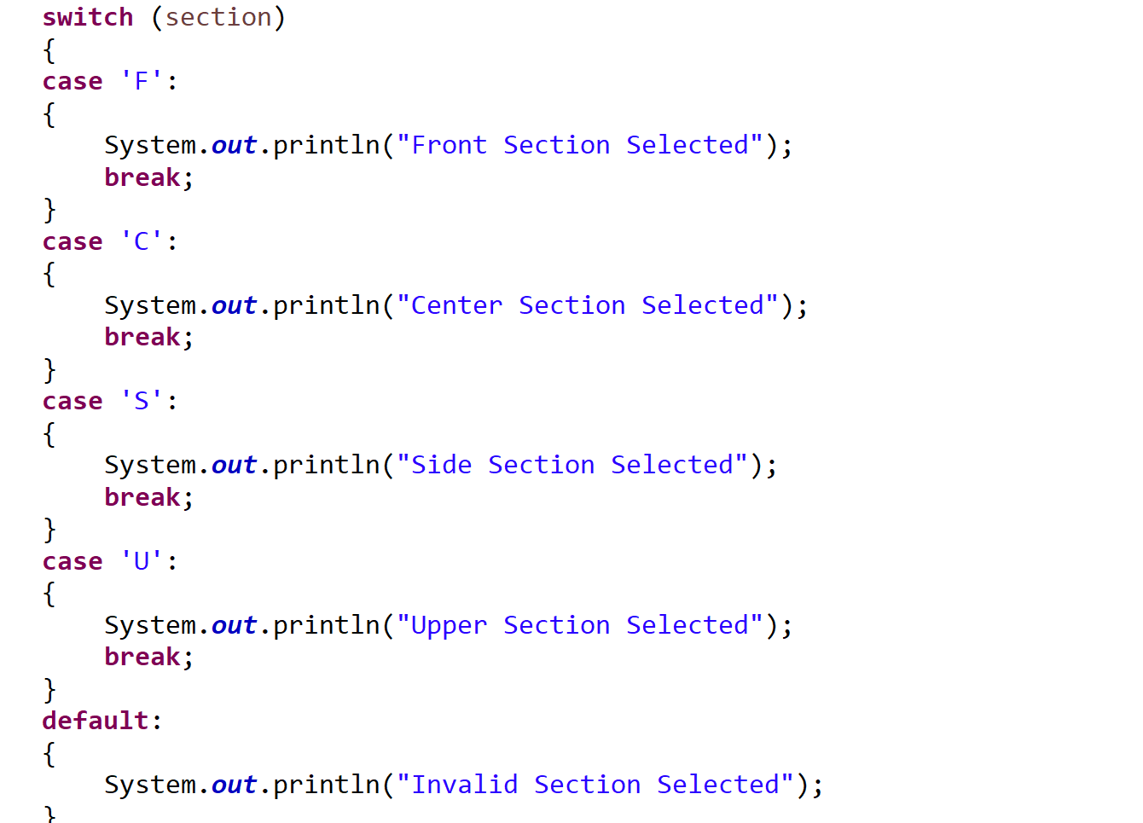
- Only use breaks in Switch Statements
- The use of a Default “case” is if no other cases match. I kind of see it as an “else” but I know it’s not
- String tells the system that a list of characters are going to be listed.
- Char is just one single character ‘a’
- Reading in a String while using next() reads whatever String was placed and stops at a white space
- You read a char by using next().charAt(0) and its reading the character at the first position of the String
- charAt(0) is reading the character in the first position. If it was "Cam" the Char would be ‘C’
- Concatenate is combining all the strings you listed as one whole print

Module 3: Loops and Methods
Add the information to demonstrate the following objectives and organize with headings:
- Compare different types of loops (for, while, do-while).
- Use sentinel values and boolean flags to control loop execution.
- Distinguish scope of variables in control structures and methods.
- Use loops and nested control structures to control program flow.
- Write and call methods to pass and return values.
- Trace memory during method calls to evaluate stack frame memory and pass-by-value.

M03 L10 Loops

++ (increment ) & -- (decrement)
- “++” adds one to the int
- -- subtract one from the int
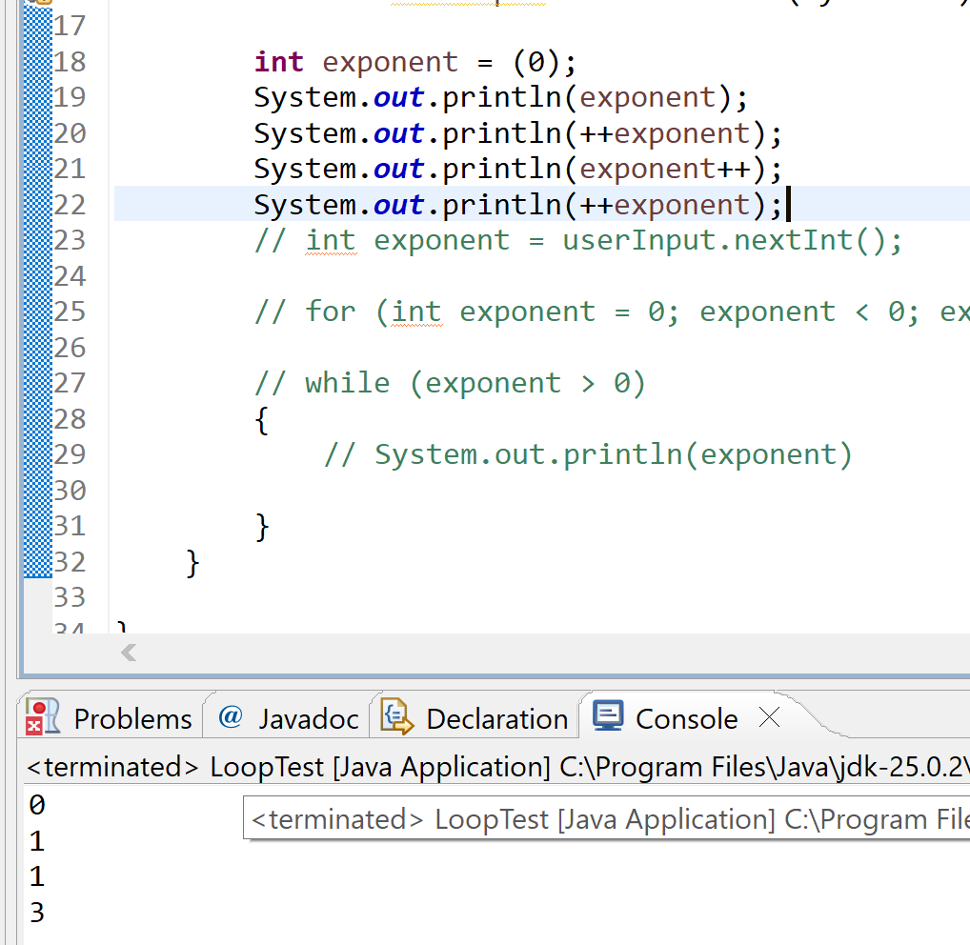 Notice how line 22 asks to print another ++ so you don’t see 2. It goes directly from 0-1-1-3

- Prefix
The ++ before the variable is the prefix. It adds 1 to the value and displays it
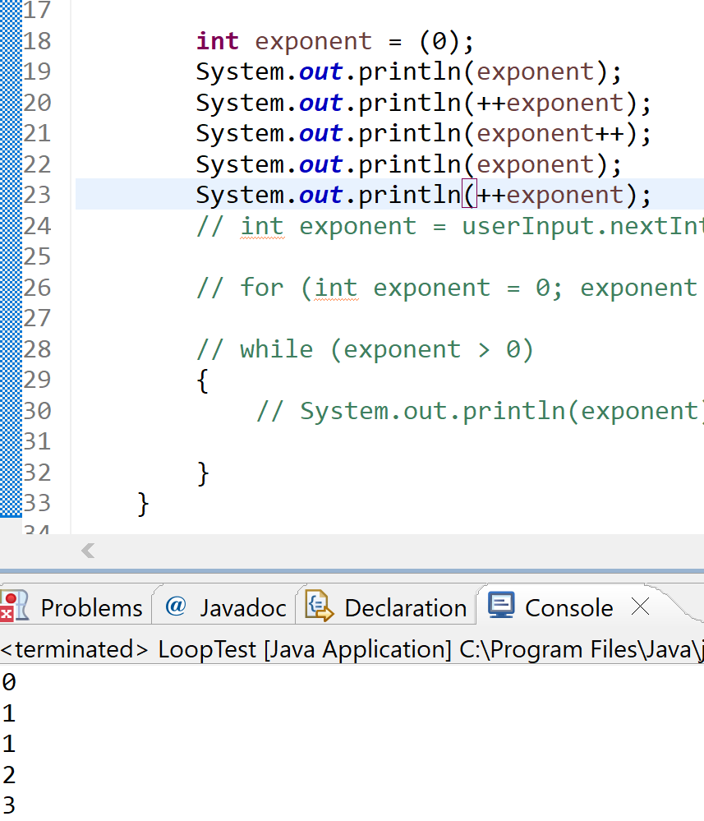

- Postfix
Still adds one to the value, but just displays the value it was holding before. So if we were to System.out.println(exponent); on the next line, console with display 0-1-1-2-2-3
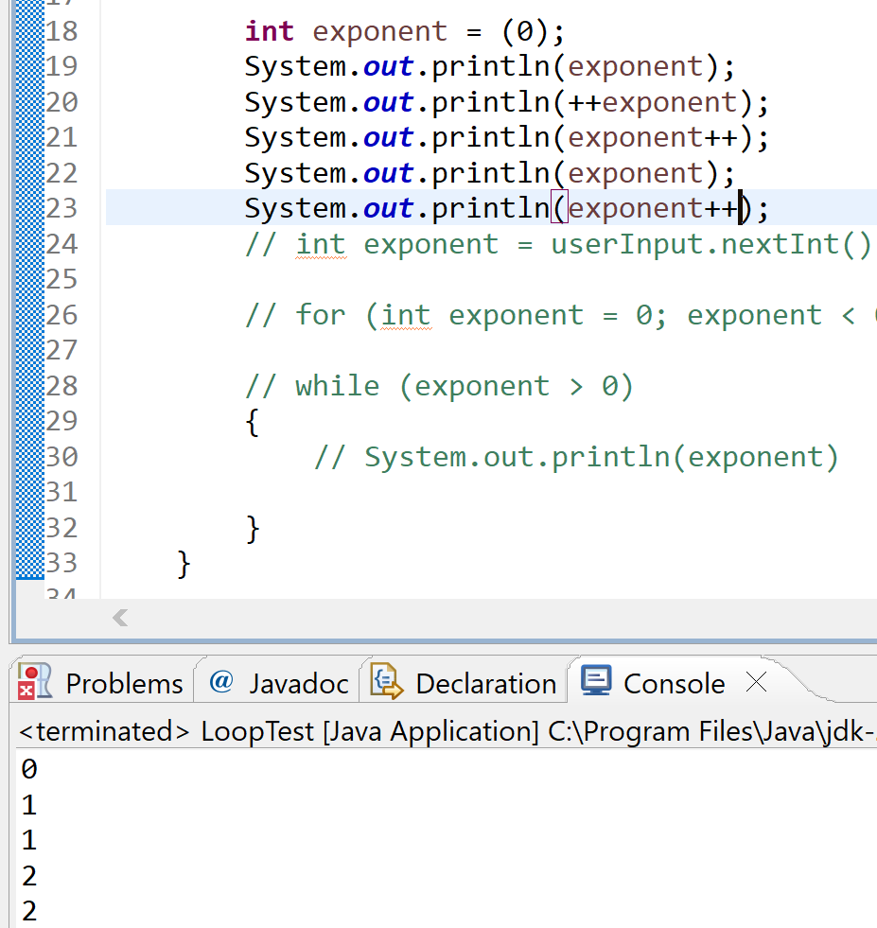

While loop
- Doesn’t need ;
- Uses braces
- Continues the loops so long as its condition is true
- Indefinite loop; used when you are unsure how many times the loop will be needed

Do while loop
- Starts with the “do” statement
- Still need brackets
- While is put at the end
- The while does need ;
- Does the command then checks if the condition is met or not to start loop
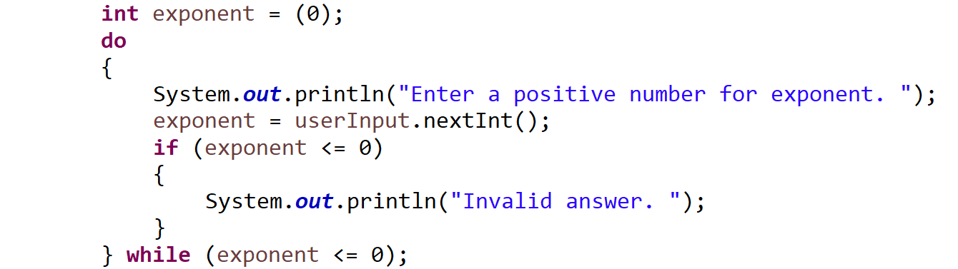
- In the code, it first displays the message, then asks for the user to enter an input for “exponent”
- If the input <= 0 it will display a message
- This prompt will continue when the exponent entered is <= 0
- If condition is met (exponent > 0) then it will continue to the next part

Sentinel value
- Specific set value
- Tests until that value is met

For loop
- Used to execute a loop, a set number of times
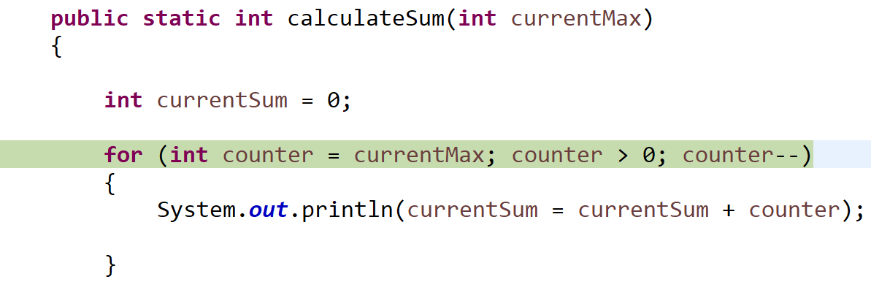
- (this example was for CalculateSum) I’m initializing the variable currentSum, then inside ( ) the for loop I am initializing the variable counter to equal currentMax (new method)
- The counter must be greater than 0 and as long counter (currentMax) is greater than 0, then it will continue the loop inside the brackets
- Semicolon separating each
- This For loop was used in a new method (not main)

How to properly exit a loop
- Don’t use returns, breaks, to exit a loop
- Use int for loops
- Infinite loops are bad

L11 Nested loop and Selection structure

Boolean flag
- Boolean is a true or false statement
- If its int number = 5
boolean test = false
While (!test) would mean a loop is created as long as long as the outcome is false (missing some extra information)

- Comparing strings
- Nested For loop
- Do not use global or static variables

L12

Creating Methods
- Public, Static, Return Type, methodName, fomal parameter list
- methodName should be a verb
- used to break up a big problem into smaller ones
- must use brackets and put inside those brackets, anything outside is not involved
- using “return” will bring the result back to the specified variable
- new methods can be called to use in other methods
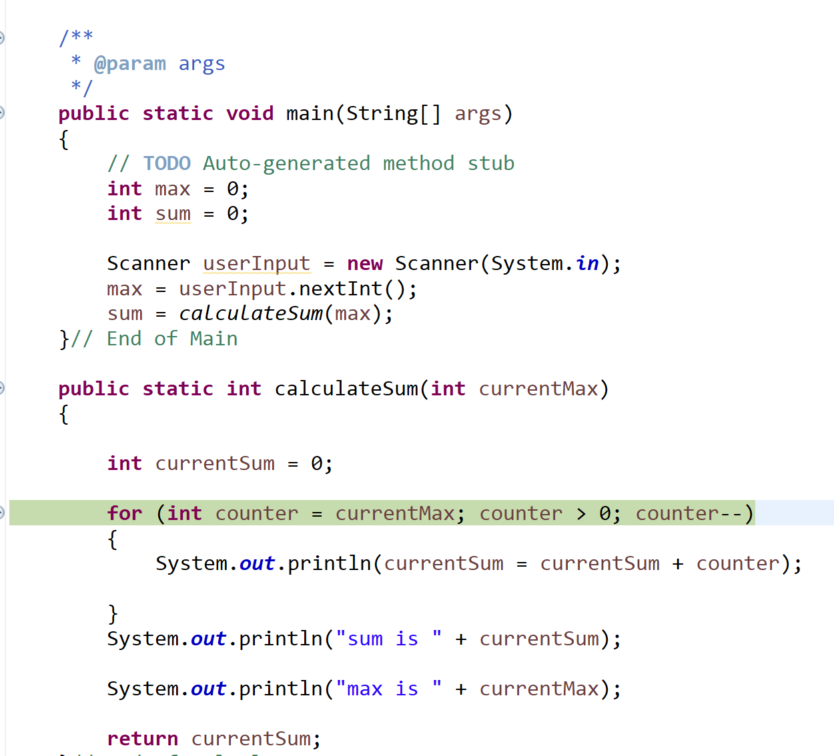

L13 Methods Pass by Value and Software Development

Method Call Stack
- Think of plates (stack frame) being stacked on top of each other
- “Push” would be stacking them in order 1, 2 , 3
- “Pop” would be reverse of that stack in order of 3, 2 ,1
- LIFO = Last in, First out
- Local variables are created when the method starts and destroyed when it ends
- The local variables are declared inside that method
- Are stored inside the method

Module 4: Arrays
Add the information to demonstrate the following objectives and organize with headings:
- Declaring, allocating, initializing 1D arrays.
- Reference variables, array memory, and out-of-bounds issues.
- Passing arrays by reference to and from methods
- Trace memory during method calls to distinguish reference variables vs. primitive variables, stack vs. heap memory allocation.
- Design algorithms for processing arrays.
- Designing methods that operate on arrays using loops.

L15 Arrays and Memory
- IndexOutOfBounds is an error that occurs if you are keying something outside of the index limit i.e. (Cameron) has an index of 6. 0 being the letter C. There is nothing at index 7 so you’d get the error
- An Array is a non primitive data type
- Array’s give us the ability to store more than one value however they must be the same data type
- Arrays are used to set a fixed value of the same type
- Allows us to access that set value under a variable name

Declaring and constructing Arrays
- Just like when we declare any variable, we start with the data type
- We then use brackets [] after the data type
- As you see in the example we have two arrays declared (finalGrades & firstNames)
- We then call those variables again like any other variable however we now create, new (data type) [array size] in this case its [students]
- Students is attached to keyboardInput
- A for-loop is used for arrays
- Once a new array is created, we cannot change the size of it
- .length is only used for arrays
- .length cannot change when the array is created
- It is used to find a certain length in the array
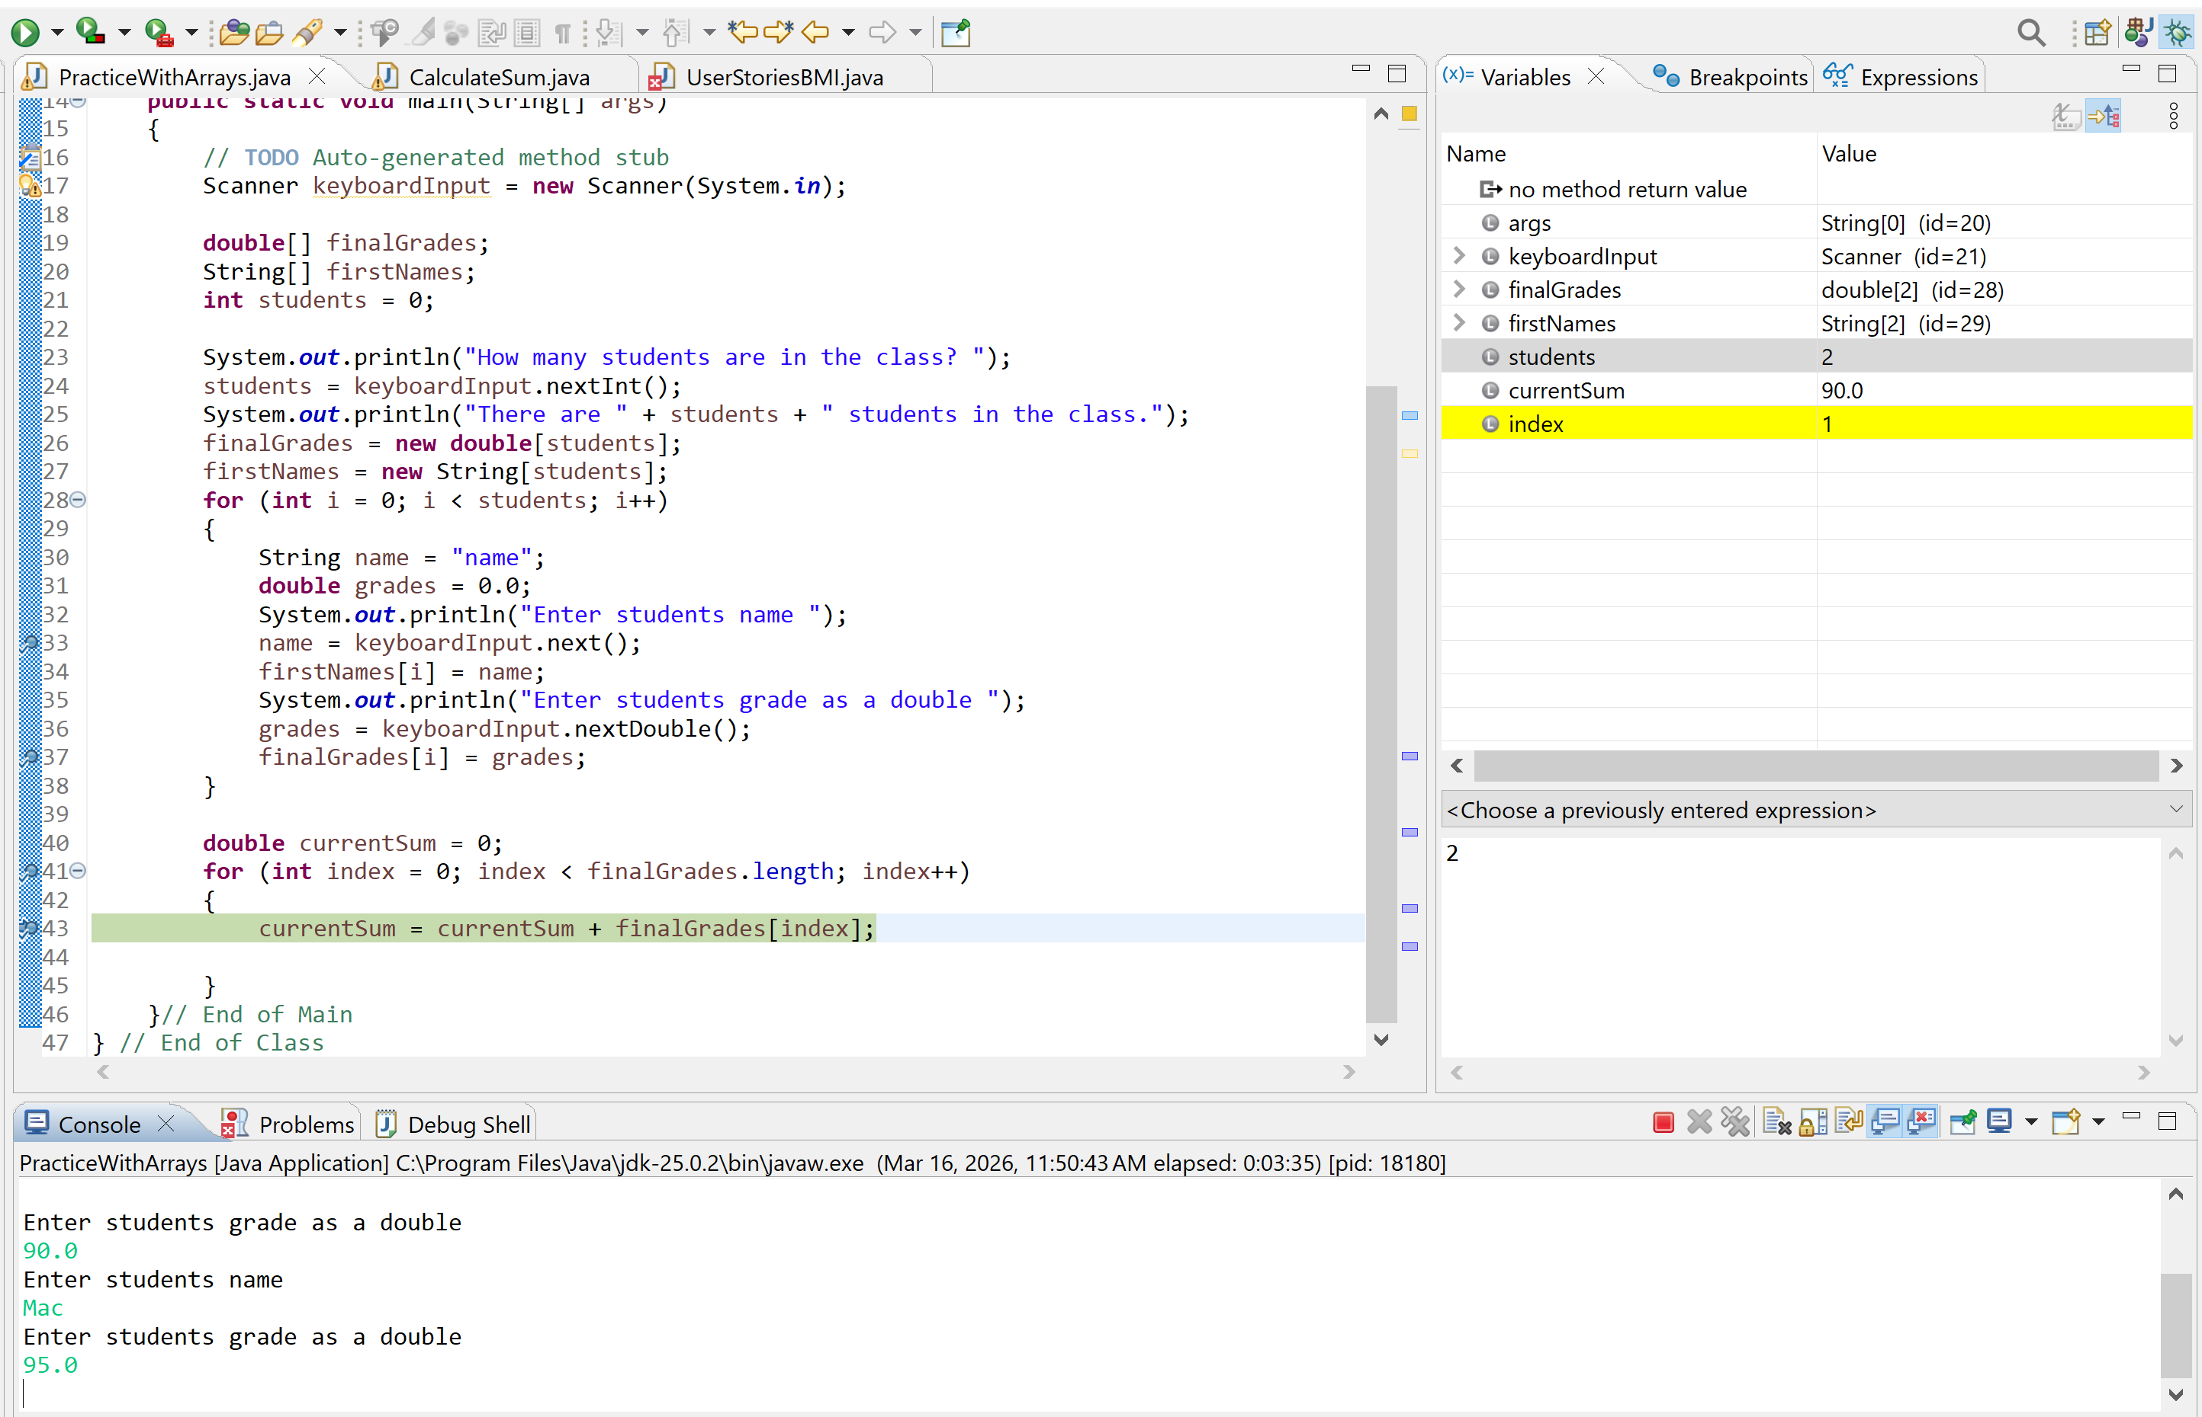

Array defaults
- Arrays have default values when created
- All depends on what’s being stored in the Array
- Null for char type
- Zero for numeric
- False for boolean

Initializing Arrays
- Initialized using a For loop
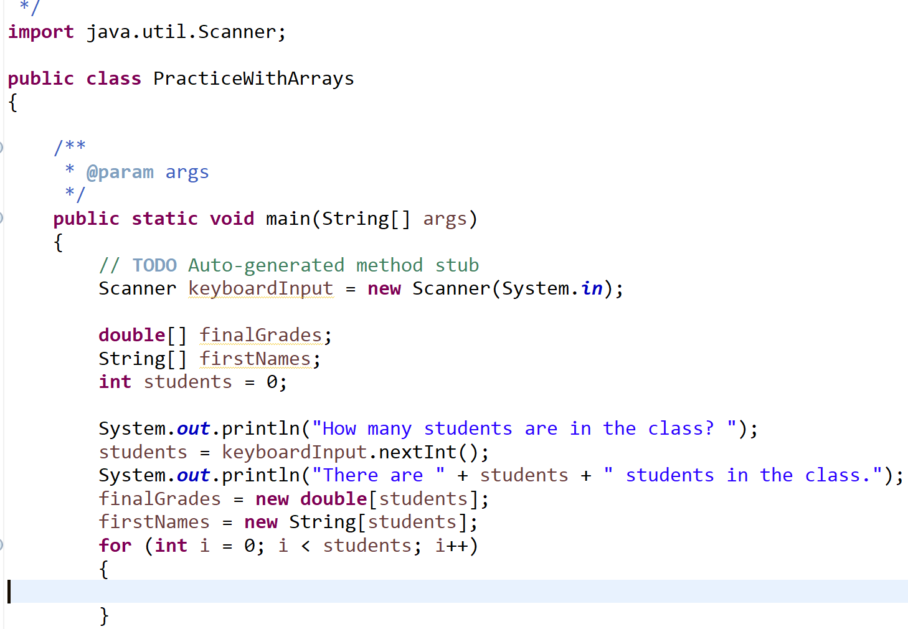
- You create, initialize, and declare the array in one line using the for-loop

Passing and Returning Arrays
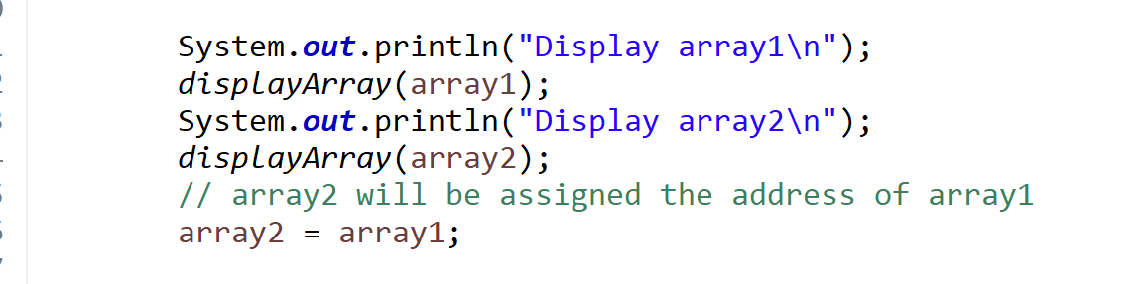
- Array2 = array1 is assigning the same memory address to each other
- In this example, array2 will be assigned the address of array1 which is 25
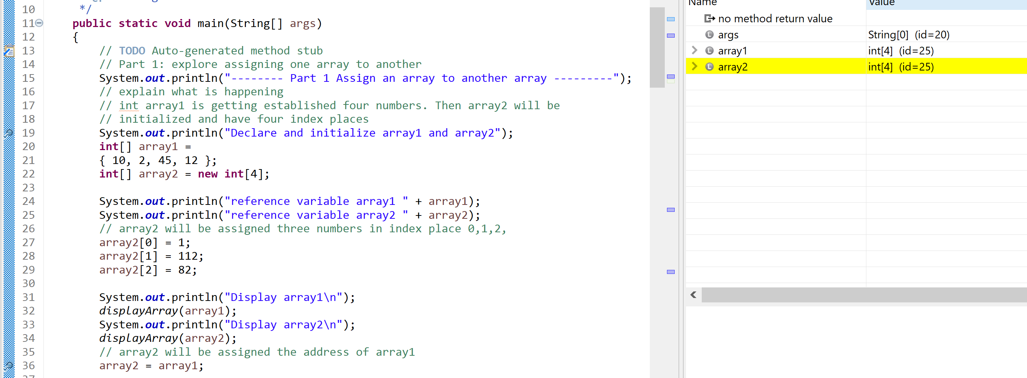
- Array2 will now be overwritten and obtain the contents of array1

Copying Arrays
(see notes in code)
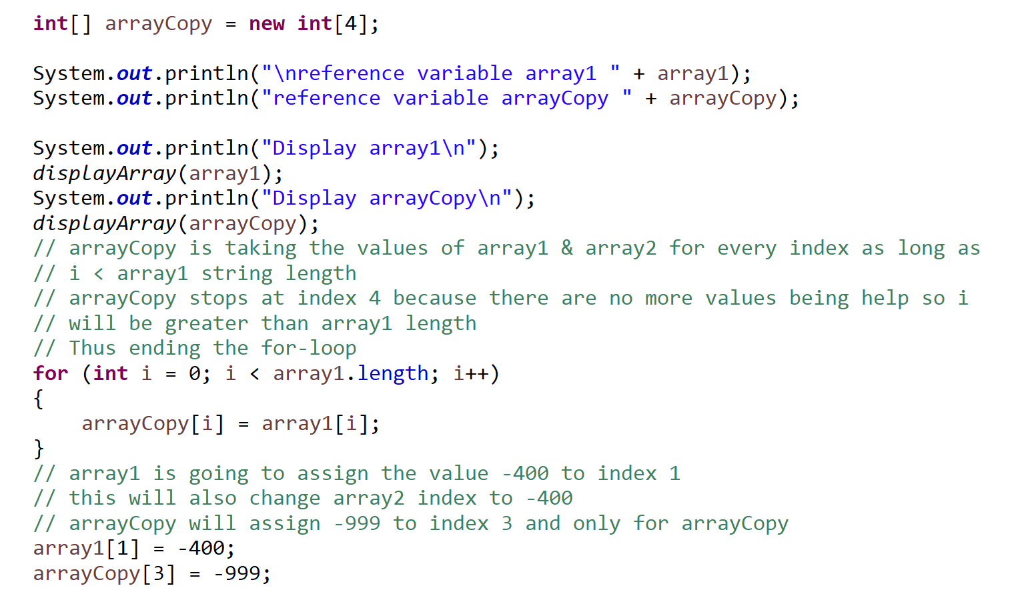

Module 5: Classes and Objects

Add the information to demonstrate the following objectives and organize with headings:
- Use classes to define blueprints for creating objects that combine data (fields) and behaviors (methods).
- Define and implement constructors, including default, parameterized, and overloaded constructors, to initialize objects in different ways
- Encapsulation using access modifiers and getters/setters to protect and manage private data.
- Reference variables for objects, stack/heap diagrams.
- Arrays of objects
- Simple file input/output
- Design Implement and Test Java classes that model real-world problems

Heading 2 Example

Heading 3 Example

